Experiment 3

:Conservation of Mechanical Energy

Name: Jonathan Goh

UID: 404901382

Date Performed: 5/2/18

Lab Section: Wednesday 8 a.m.

TA: She, Zhenyu

Partner: Daniel Schwartz

**Worksheet:**

1. Discussion

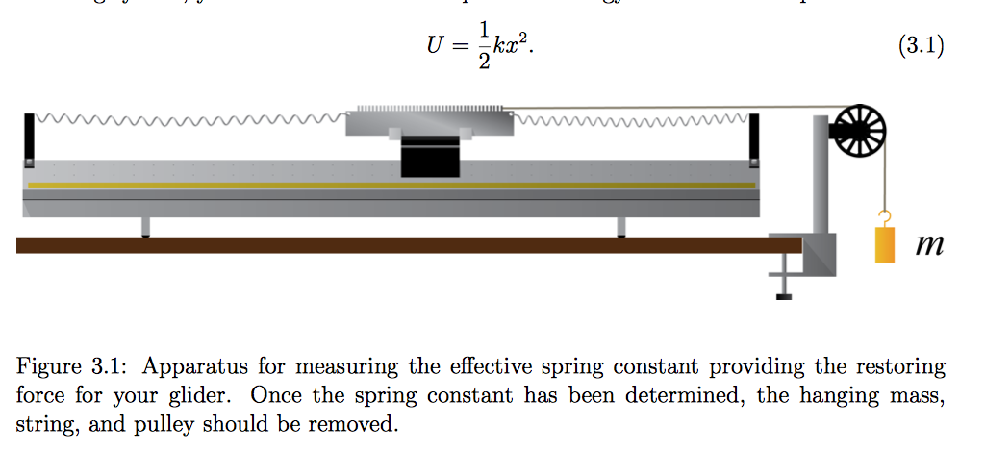

As depicted in **Figure 3.1**, the equilibrium position of the apparatus was at the 30th tooth (which was the exact center) of the photogate comb. In order to collect data, the glider was pulled in the left direction, data of the restorative force was gathered as a result of the leftward displacement.

To calculate the Potential and Kinetic Energies at the same position in space, the first step should be to calculate the spring constant ($k$) of the springs used in the system. Given the equation $F=kx$ and that $F=mg$, the value of $k$ can be solved for by rearranging the equation to $k=mg/x$, which is also the slope of a Force vs. Position graph.

The next step is to calculate the velocity at a given displacement using the equation $v(\underline{x}(i))=(\frac{Δx}{Δt})=(\frac{x{}_{i+1}-x{}_{i}}{t{}_{i+1}-t{}_{i}})$. An important thing to note is that $\underline{x}(i)$ is the average of the time interval of velocity, therefore, $\underline{x}(i)=\frac{1}{2}(x{}_{i+1}+x{}_{i})$.

With the velocity and displacement functions defined, calculating Kinetic Energy and Potential Energy is straightforward. By using the restoring force of a string $\frac{1}{2}kx^{2}$ we get: $U(\underline{x}(i))=\frac{1}{2}k({\underline{x}(i)}^{2})$. Similarly, by using the kinetic energy formula $\frac{1}{2}mv^{2}$ we get: $K(\underline{x}(i))=\frac{1}{2}m{(v(i)}^{2})$

1. Plots and Graphs

Mass of the glider with the photogate comb: 224 grams

|  |  |  |
| --- | --- | --- |
| **Hanging Mass (kg)** | **Position of Glider (m)** | **Applied Force (N)** |
| 0 ± 0.0005 | 0 ± 0.005 | 0 ± 0.005 |
| 0.0020 ± 0.0005 | 0.033 ± 0.005 | 0.196 ± 0.005 |
| 0.0060 ± 0.0005 | 0.091 ± 0.005 | 0.588 ± 0.005 |
| 0.0100 ± 0.0005 | 0.161 ± 0.005 | 0.98 ± 0.005 |
| 0.0120 ± 0.0005 | 0.193 ± 0.005 | 1.176 ± 0.005 |
| 0.0160 ± 0.0005 | 0.262 ± 0.005 | 1.568 ± 0.005 |

**Figure 3.2**: Table of raw data used to calculate the spring constant (k).

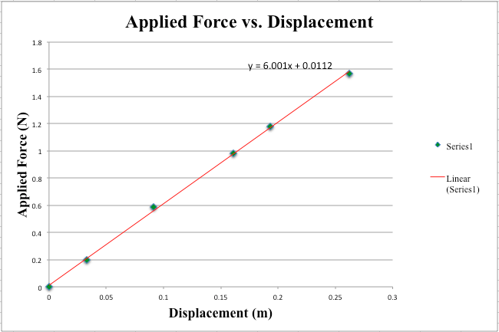

**Figure 3.3**: Plot to determine the spring constant. Returning a k-value of 6.001 ± 0.088 N

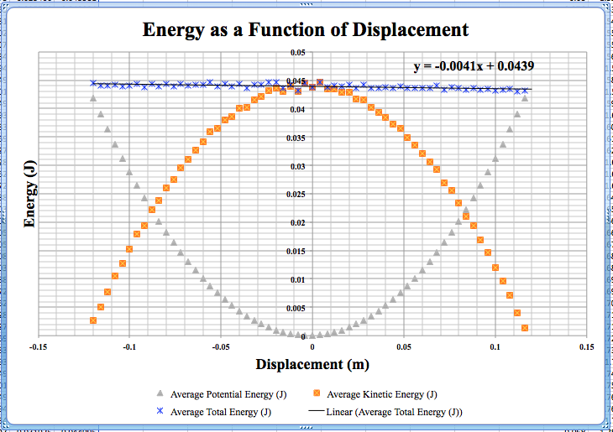

**Figure 3.4**: Plot of Potential, Kinetic, and Total Mechanical Energy of the glider. Plot confirms that there is conservation of energy throughout the glider system. Slope of Total Energy of the system is approximately -0.0041 ± 0.002 J/m.

**Calculating Value of Coefficient of Friction Between Glider and Track:**

To calculate the Coefficient of Friction we use the slope of the Total Energy of the system. The slope represents the amount of energy lost per meter, which is also equal to the Force of Friction.

Therefore:

Normal Force = Weight = mg = m(9.8)

Normal Force = (0.244 ± 0.00005) (9.8) = 2.3912 ± 0.0005

Slope of Total Energy = Force of Friction = μ *Normal Force

Rearrange the Equation to Isolate μ:

$μ=\frac{Slope of Total Energy}{Normal Force}$

$μ=\frac{-0.0041 ± 0.002}{2.3912 ± 0.0005}$

$μ= 0.0172 ± 0.0008$

**Bibliography:**

1. Campbell, W. C. et al. Physics 4AL: Mechanics Lab Manual (ver. August 31, 2017). (Univ. California Los Angeles, Los Angeles, California).

**Presentation Mini-Report**

Proving Conservation of Mechanical Energy

J.R. Goh1

Based on Newton’s Laws of Physics it is assumed that if there are only conservative forces in a system, then mechanical energy is conserved. The experimental system consisted of a spring attached to each end of a photogate comb atop a glider and an, almost frictionless, air-track. Data was collected from photogate sensors set at the equilibrium position of the glider apparatus after dangling various masses at the end of the glider. To show that conservation of mechanical energy held true, the spring constant was calculated by observing the slope of the trendline of the applied force versus the displacement of the glider. Next, time data for a half oscillation of the glider was recorded. Given the spacing between successive photogate teeth, displacement was recorded and velocity was derived from displacement and time. Kinetic energy was calculated using the glider mass and velocity, while potential energy used the spring constant and the average displacement. Heat given off from friction caused the slight loss of total energy. A plot of the energies shows that the loss of potential energy is equal to the gain in kinetic energy and vice-versa, taking into account slight losses of energy due to friction.

1 *Department of Engineering, Henry Samueli School of Engineering and Applied Sciences, University of California Los Angeles.*